EXPERIMENT 25:

Merge Operations

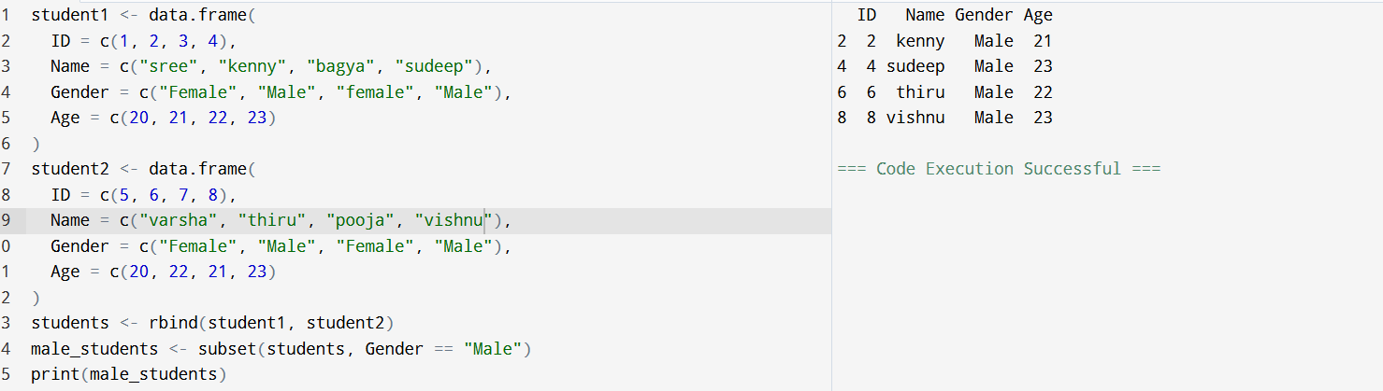

EXPERIMENT 26:

Binding Operations

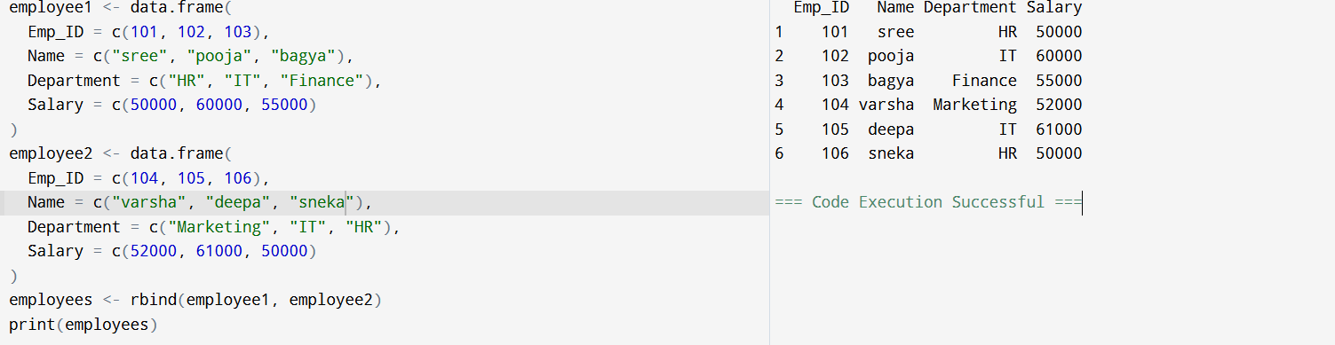

EPERIMENT 27:

Melting and Casting

